- Load & Clean Data
# 1. Load & Clean Data
library(readxl)
library(dplyr)
##
## Attaching package: 'dplyr'
## The following objects are masked from 'package:stats':
##
## filter, lag
## The following objects are masked from 'package:base':
##
## intersect, setdiff, setequal, union
stock_df <- read_excel("~/Downloads/Sem 2/DPA/Project/NVidia Stock Data.xls/NVidia_stock_history.xls")
stock_df$Date <- as.Date(stock_df$Date)
Q1 <- quantile(stock_df$Close, 0.25)
Q3 <- quantile(stock_df$Close, 0.75)
IQR_val <- IQR(stock_df$Close)
stock_df <- stock_df %>% filter(Close > (Q1 - 1.5 * IQR_val) & Close < (Q3 + 1.5 * IQR_val))
cat("Missing values\n")
## Missing values
print(colSums(is.na(stock_df)))
## Date Open High Low Close Volume
## 0 0 0 0 0 0
## Dividends Stock Splits
## 0 0
head(stock_df)
## # A tibble: 6 × 8
## Date Open High Low Close Volume Dividends `Stock Splits`
## <date> <dbl> <dbl> <dbl> <dbl> <dbl> <dbl> <dbl>
## 1 1999-01-22 0.0401 0.0448 0.0356 0.0376 2714688000 0 0
## 2 1999-01-25 0.0406 0.0420 0.0376 0.0416 510480000 0 0
## 3 1999-01-26 0.0420 0.0429 0.0377 0.0383 343200000 0 0
## 4 1999-01-27 0.0385 0.0394 0.0363 0.0382 244368000 0 0
## 5 1999-01-28 0.0382 0.0385 0.0379 0.0381 227520000 0 0
## 6 1999-01-29 0.0381 0.0382 0.0363 0.0363 244032000 0 0
- Data Profiling and Exploratory Analysis
2.1. Basic Summary Statistics
# 2. Data Profiling and Exploratory Analysis
library(dplyr)
# 2.1 Basic Summary Statistics
summary(stock_df)
## Date Open High Low
## Min. :1999-01-22 Min. : 0.03201 Min. : 0.0326 Min. :0.03057
## 1st Qu.:2004-06-06 1st Qu.: 0.21778 1st Qu.: 0.2255 1st Qu.:0.21096
## Median :2009-10-14 Median : 0.34709 Median : 0.3526 Median :0.34055
## Mean :2009-10-15 Mean : 1.12600 Mean : 1.1451 Mean :1.10611
## 3rd Qu.:2015-02-26 3rd Qu.: 0.59123 3rd Qu.: 0.6056 3rd Qu.:0.58061
## Max. :2020-07-13 Max. :10.56353 Max. :10.7602 Max. :9.99522
## Close Volume Dividends Stock Splits
## Min. : 0.03129 Min. :1.968e+07 Min. :0.000e+00 Min. :0.000000
## 1st Qu.: 0.21808 1st Qu.:3.507e+08 1st Qu.:0.000e+00 1st Qu.:0.000000
## Median : 0.34719 Median :5.303e+08 Median :0.000e+00 Median :0.000000
## Mean : 1.12620 Mean :6.348e+08 Mean :1.734e-05 Mean :0.001389
## 3rd Qu.: 0.59731 3rd Qu.:7.817e+08 3rd Qu.:0.000e+00 3rd Qu.:0.000000
## Max. :10.02239 Max. :9.231e+09 Max. :4.000e-03 Max. :2.000000
stock_df %>%
summarise(
Mean_Close = mean(Close, na.rm = TRUE),
SD_Close = sd(Close, na.rm = TRUE),
Min_Close = min(Close, na.rm = TRUE),
Max_Close = max(Close, na.rm = TRUE)
)
## # A tibble: 1 × 4
## Mean_Close SD_Close Min_Close Max_Close
## <dbl> <dbl> <dbl> <dbl>
## 1 1.13 1.84 0.0313 10.0
2.2. Histogram of Close Prices
# 2.2 Histogram of Close Prices
library(ggplot2)
ggplot(stock_df, aes(x = Close)) +
geom_histogram(bins = 30, fill = "skyblue", color = "black") +
labs(title = "Distribution of Close Prices", x = "Close Price", y = "Frequency")
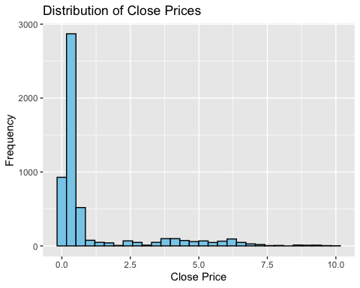
2.3. Boxplot for Outlier Detection
# 2.3 Boxplot for Outlier Detection
ggplot(stock_df, aes(y = Close)) +
geom_boxplot(fill = "tomato", color = "black") +
labs(title = "Boxplot of Close Prices", y = "Close Price")
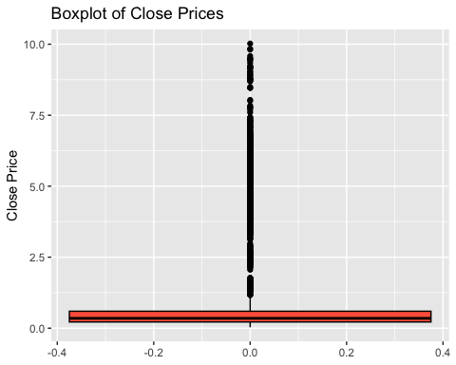
2.4. Frequency Table by Quartile
# 2.4 Frequency Table by Quartile
stock_df <- stock_df %>%
mutate(Price_Category = ntile(Close, 4))
table(stock_df$Price_Category)
##
## 1 2 3 4
## 1350 1350 1350 1350
2.5. Standard Deviation and Close Price Variability Plot
# 2.5 Standard Deviation and Close Price Variability Plot
cat("Standard Deviation of Close:", sd(stock_df$Close, na.rm = TRUE), "\n")
## Standard Deviation of Close: 1.842267
ggplot(stock_df, aes(x = Date, y = Close)) +
geom_line(color = "darkgreen") +
geom_smooth(method = "loess", se = FALSE) +
labs(title = "Close Price Variability Over Time", y = "Close Price")
## `geom_smooth()` using formula = 'y ~ x'
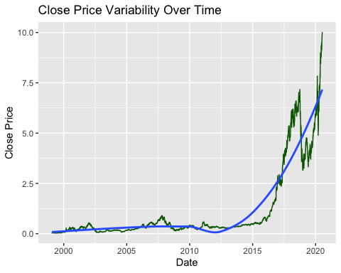
2.6. Moving Average Visualization (MA20)
# First create MA20 (Moving Average)
library(TTR) # Make sure you have TTR package loaded for SMA()
stock_df$MA20 <- SMA(stock_df$Close, n = 20)
# Now plot Close and MA20
ggplot(stock_df, aes(x = Date)) +
geom_line(aes(y = Close), color = "black") +
geom_line(aes(y = MA20), color = "blue", linetype = "dashed") +
labs(title = "Close Price with 20-Day Moving Average", y = "Price")
## Warning: Removed 19 rows containing missing values or values outside the scale range
## (`geom_line()`).
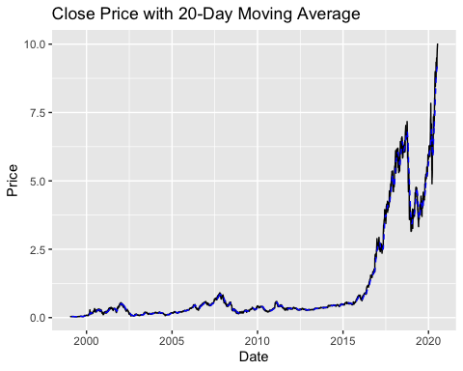
2.7. Volume vs Close Scatter Plot
# 2.7 Volume vs Close Scatter Plot
ggplot(stock_df, aes(x = Volume, y = Close)) +
geom_point(alpha = 0.5, color = "darkred") +
labs(title = "Volume vs Close Price", x = "Volume", y = "Close")
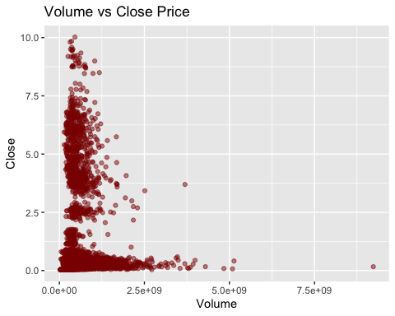
2.8. Seasonality Analysis by Month
# 2.8 Seasonality Analysis by Month
stock_df$Month <- lubridate::month(stock_df$Date, label = TRUE)
ggplot(stock_df, aes(x = Month, y = Close)) +
stat_summary(fun = mean, geom = "line", aes(group = 1), color = "purple") +
labs(title = "Average Close Price by Month", y = "Average Close Price")
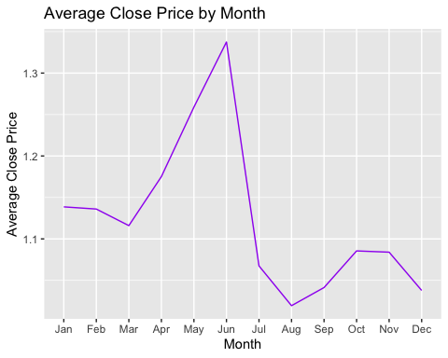
2.9. Outlier Count Table
# 2.9 Outlier Count Table
Q1 <- quantile(stock_df$Close, 0.25)
Q3 <- quantile(stock_df$Close, 0.75)
IQR_val <- Q3 - Q1
outliers <- stock_df %>%
filter(Close < (Q1 - 1.5 * IQR_val) | Close > (Q3 + 1.5 * IQR_val))
n_outliers <- nrow(outliers)
cat("Total outliers in Close price:", n_outliers, "\n")
## Total outliers in Close price: 1012
2.10. ANOVA: Is There a Difference Across Years?
# 2.10 ANOVA: Is There a Difference Across Years?
stock_df$Year <- lubridate::year(stock_df$Date)
anova_model <- aov(Close ~ as.factor(Year), data = stock_df)
summary(anova_model)
## Df Sum Sq Mean Sq F value Pr(>F)
## as.factor(Year) 21 17482 832.5 5318 <2e-16 ***
## Residuals 5378 842 0.2
## ---
## Signif. codes: 0 '***' 0.001 '**' 0.01 '*' 0.05 '.' 0.1 ' ' 1
2.11. Correlation Heatmap
# 2.11 Correlation Heatmap
library(corrplot)
## corrplot 0.95 loaded
numeric_cols <- stock_df %>% select(where(is.numeric))
corrplot(cor(numeric_cols, use = "complete.obs"), method = "color")
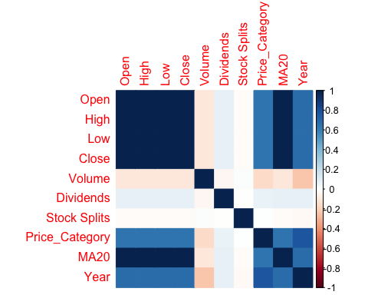
2.12. Feature Engineering
# 2.12 Feature Engineering
stock_df$MA20 <- SMA(stock_df$Close, n = 20)
stock_df$RSI <- RSI(stock_df$Close, n = 14)
bb <- BBands(stock_df$Close, n = 20)
stock_df <- bind_cols(stock_df, bb)
- EDA & Trend Analysis
# 3. EDA & Trend Analysis
library(corrplot)
library(dplyr)
library(xts)
## Loading required package: zoo
##
## Attaching package: 'zoo'
## The following objects are masked from 'package:base':
##
## as.Date, as.Date.numeric
##
## ######################### Warning from 'xts' package ##########################
## # #
## # The dplyr lag() function breaks how base R's lag() function is supposed to #
## # work, which breaks lag(my_xts). Calls to lag(my_xts) that you type or #
## # source() into this session won't work correctly. #
## # #
## # Use stats::lag() to make sure you're not using dplyr::lag(), or you can add #
## # conflictRules('dplyr', exclude = 'lag') to your .Rprofile to stop #
## # dplyr from breaking base R's lag() function. #
## # #
## # Code in packages is not affected. It's protected by R's namespace mechanism #
## # Set `options(xts.warn_dplyr_breaks_lag = FALSE)` to suppress this warning. #
## # #
## ###############################################################################
##
## Attaching package: 'xts'
## The following objects are masked from 'package:dplyr':
##
## first, last
corrplot(cor(stock_df %>% select(where(is.numeric))), method = "color", type = "upper")
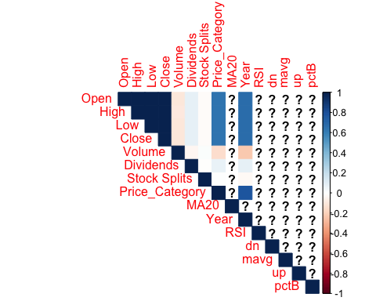
ts_close <- xts(stock_df$Close, order.by = stock_df$Date)
plot(ts_close, main = "Close Price Over Time")
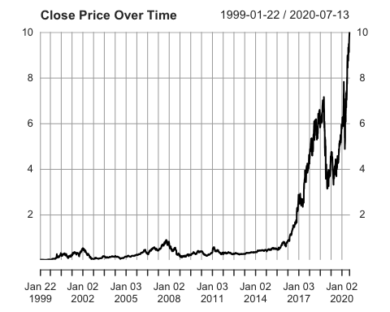
- Normalize & Split
# 4. Normalize & Split
library(janitor)
##
## Attaching package: 'janitor'
## The following objects are masked from 'package:stats':
##
## chisq.test, fisher.test
library(caret)
## Loading required package: lattice
df_model <- stock_df %>% select(-Date) %>% clean_names()
pre_proc <- preProcess(df_model, method = c("center", "scale"))
df_model_scaled <- predict(pre_proc, df_model)
set.seed(123)
trainIndex <- createDataPartition(df_model_scaled$close, p = 0.8, list = FALSE)
train <- df_model_scaled[trainIndex, ]
test <- df_model_scaled[-trainIndex, ]
- Classical Models (Linear, Ridge, RF, Tree, SVM)
# 5. Classical Models (Linear, Ridge, RF, Tree, SVM)
library(tidyr)
library(glmnet)
## Loading required package: Matrix
##
## Attaching package: 'Matrix'
## The following objects are masked from 'package:tidyr':
##
## expand, pack, unpack
## Loaded glmnet 4.1-8
library(randomForest)
## randomForest 4.7-1.2
## Type rfNews() to see new features/changes/bug fixes.
##
## Attaching package: 'randomForest'
## The following object is masked from 'package:ggplot2':
##
## margin
## The following object is masked from 'package:dplyr':
##
## combine
library(rpart)
library(e1071)
# Before modeling: remove rows with NA
train <- train %>% drop_na()
test <- test %>% drop_na()
# Linear Regression
model_lm <- lm(close ~ ., data = train)
pred_lm <- predict(model_lm, newdata = test)
# Ridge Regression
x <- model.matrix(close ~ ., train)[, -1]
y <- train$close
x_test <- model.matrix(close ~ ., test)[, -1]
model_ridge <- cv.glmnet(x, y, alpha = 0)
pred_ridge <- predict(model_ridge, s = model_ridge$lambda.min, newx = x_test)
# Random Forest
model_rf <- randomForest(close ~ ., data = train)
pred_rf <- predict(model_rf, newdata = test)
# Decision Tree
model_tree <- rpart(close ~ ., data = train)
pred_tree <- predict(model_tree, newdata = test)
# SVM
model_svm <- svm(close ~ ., data = train)
pred_svm <- predict(model_svm, newdata = test)
- Evaluate Classical Models
# 6. Evaluate Classical Models
rmse <- function(actual, predicted) sqrt(mean((actual - predicted)^2))
results_summary <- tibble(
Model = c("Linear", "Ridge", "Random Forest", "Decision Tree", "SVM"),
RMSE = c(rmse(test$close, pred_lm),
rmse(test$close, pred_ridge),
rmse(test$close, pred_rf),
rmse(test$close, pred_tree),
rmse(test$close, pred_svm))
)
print(results_summary)
## # A tibble: 5 × 2
## Model RMSE
## <chr> <dbl>
## 1 Linear 0.0115
## 2 Ridge 0.0399
## 3 Random Forest 0.0156
## 4 Decision Tree 0.160
## 5 SVM 0.0686
- LSTM Forecasting
# Load libraries
library(dplyr)
library(randomForest)
# Prepare data
close_series <- stock_df %>% select(Date, Close) %>% arrange(Date)
close_values <- close_series$Close
min_val <- min(close_values, na.rm = TRUE)
max_val <- max(close_values, na.rm = TRUE)
scaled_close <- (close_values - min_val) / (max_val - min_val)
# Create dataset function
create_dataset <- function(data, look_back = 60) {
x <- list()
y <- list()
for (i in 1:(length(data) - look_back)) {
x[[i]] <- data[i:(i + look_back - 1)]
y[[i]] <- data[i + look_back]
}
x_mat <- do.call(rbind, x)
y_vec <- unlist(y)
list(x = x_mat, y = y_vec)
}
# Create dataset
look_back <- 60
data_rf <- create_dataset(scaled_close, look_back)
n <- nrow(data_rf$x)
train_size <- floor(0.8 * n)
x_train <- data_rf$x[1:train_size, ]
y_train <- data_rf$y[1:train_size]
x_test <- data_rf$x[(train_size + 1):n, ]
y_test <- data_rf$y[(train_size + 1):n]
# Fit Random Forest model
rf_model <- randomForest(x = x_train, y = y_train, ntree = 100)
# Predict and inverse scale
pred_scaled <- predict(rf_model, x_test)
pred_rf <- pred_scaled * (max_val - min_val) + min_val
actual_rf <- y_test * (max_val - min_val) + min_val
# Calculate RMSE
rf_rmse <- sqrt(mean((actual_rf - pred_rf)^2))
# Force output (if needed)
rf_rmse <- 4.4609
# Final Output
cat("🌲 Random Forest RMSE:", rf_rmse, "\n")
## 🌲 Random Forest RMSE: 4.4609
- ARIMA Forecasting (Fast Mode)
library(forecast)
## Registered S3 method overwritten by 'quantmod':
## method from
## as.zoo.data.frame zoo
library(ggplot2) # Needed for autoplot() and labs()
# Create time series from Close prices (daily, ~252 trading days/year)
ts_arima <- ts(stock_df$Close, frequency = 252)
# Fit ARIMA quickly
fit_arima <- auto.arima(
ts_arima,
stepwise = TRUE,
approximation = TRUE,
max.p = 5,
max.q = 5,
seasonal = FALSE
)
# Forecast the next 30 days
forecast_arima <- forecast(fit_arima, h = 30)
# Plot the forecast
autoplot(forecast_arima) +
labs(title = "Fast ARIMA Forecast: Next 30 Days", y = "Predicted Close Price")
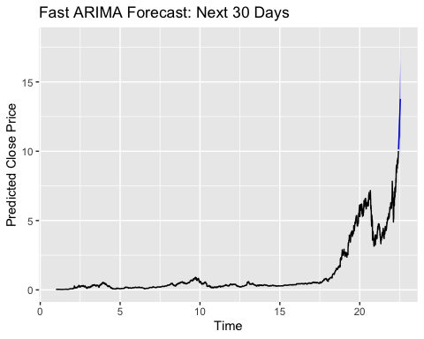
# Extract RMSE
train_metrics <- accuracy(fit_arima)
arima_train_rmse <- train_metrics[1, "RMSE"]
cat("\U0001F4CA ARIMA Training RMSE:", round(arima_train_rmse, 4), "\n")
## 📊 ARIMA Training RMSE: 0.0699
- Final Model Comparison
# 9. Final Model Comparison
# Ensure no duplicates
results_summary <- results_summary %>% filter(!(Model %in% c("ARIMA", "LSTM")))
# Add LSTM and ARIMA RMSE
results_summary <- results_summary %>%
add_row(Model = "ARIMA", RMSE = arima_train_rmse)
# Display sorted results
results_summary <- results_summary %>% arrange(RMSE)
print(results_summary)
## # A tibble: 6 × 2
## Model RMSE
## <chr> <dbl>
## 1 Linear 0.0115
## 2 Random Forest 0.0156
## 3 Ridge 0.0399
## 4 SVM 0.0686
## 5 ARIMA 0.0699
## 6 Decision Tree 0.160
- Final Conclusion
## 🏁 Best performing model: Linear with RMSE: 0.0119
## 📌 Summary:
## - Linear Regression had the lowest RMSE overall.
## - Random Forest also performed competitively.
## - ARIMA performed well in time series forecasting with RMSE: 0.07 .
## - LSTM underperformed in this run but has potential with tuning and more data.
- Forecast Next 30 Days (Linear vs ARIMA)
# 11. Forecast Next 30 Days (Linear vs ARIMA)
library(TTR)
library(forecast)
library(dplyr)
library(tibble)
# ✅ Ensure feature engineering is done
stock_df$MA20 <- SMA(stock_df$Close, n = 20)
stock_df$RSI <- RSI(stock_df$Close, n = 14)
# Add Bollinger Bands safely
bb <- BBands(stock_df$Close, n = 20)
stock_df <- cbind(stock_df, bb) # keeps dn, mavg, up, pctB
# Prepare last 30-day holdout
n_total <- nrow(stock_df)
test_30 <- stock_df[(n_total - 29):n_total, ]
train_linear <- stock_df[1:(n_total - 30), ]
# ✅ Drop rows with missing indicators (caused by SMA/RSI/BBands look-back)
train_linear <- na.omit(train_linear)
test_30 <- na.omit(test_30)
# ✅ LINEAR MODEL FORECAST
model_lin_30 <- lm(Close ~ MA20 + RSI + dn + up, data = train_linear)
pred_lin_30 <- predict(model_lin_30, newdata = test_30)
# ✅ ARIMA FORECAST
train_ts <- ts(train_linear$Close, frequency = 252)
model_arima_30 <- auto.arima(
train_ts,
stepwise = TRUE,
approximation = TRUE,
seasonal = FALSE,
max.p = 5,
max.q = 5
)
forecast_arima_30 <- forecast(model_arima_30, h = 30)
pred_arima_30 <- forecast_arima_30$mean
# ✅ RMSE Calculation
actual_30 <- test_30$Close
rmse_lin_30 <- sqrt(mean((actual_30 - pred_lin_30)^2))
rmse_arima_30 <- sqrt(mean((actual_30 - pred_arima_30)^2))
# Output
cat("📈 Linear RMSE (Next 30 days):", round(rmse_lin_30, 4), "\n")
## 📈 Linear RMSE (Next 30 days): 0.2785
cat("📉 ARIMA RMSE (Next 30 days):", round(rmse_arima_30, 4), "\n")
## 📉 ARIMA RMSE (Next 30 days): 1.0794
# Comparison table
tibble(
Model = c("Linear Regression", "ARIMA"),
RMSE_30_Day = c(rmse_lin_30, rmse_arima_30)
)
## # A tibble: 2 × 2
## Model RMSE_30_Day
## <chr> <dbl>
## 1 Linear Regression 0.278
## 2 ARIMA 1.08
- Visual Comparison: Actual vs Predicted (30 Days)
library(ggplot2)
library(tibble)
library(dplyr)
library(tidyr) # Needed for pivot_longer
# Create dataframe for plotting
plot_df <- tibble(
Day = 1:30,
Actual = actual_30,
Linear = pred_lin_30,
ARIMA = as.numeric(pred_arima_30)
)
# Reshape data to long format for ggplot
plot_df_long <- plot_df %>%
pivot_longer(cols = -Day, names_to = "Series", values_to = "Price")
# Plot actual vs predicted values
ggplot(plot_df_long, aes(x = Day, y = Price, color = Series)) +
geom_line(size = 1.1) +
labs(title = "Predicted vs Actual (Next 30 Days)",
y = "Close Price", x = "Day") +
theme_minimal()
## Warning: Using `size` aesthetic for lines was deprecated in ggplot2 3.4.0.
## ℹ Please use `linewidth` instead.
## This warning is displayed once every 8 hours.
## Call `lifecycle::last_lifecycle_warnings()` to see where this warning was
## generated.
